EXP-1 1.1
clc;
clear

Fs = 10000;
Fp = 1000;
Fst = 1500;

% Minimum order calculation
[N,Wn] = buttord(Fp/(Fs/2), Fst/(Fs/2), 1, 60);
[b,a] = butter(N,Wn);

% Magnitude & Phase
figure
freqz(b,a);
title('Magnitude & Phase Response');

% Impulse Response
figure
[h,n] = impz(b,a,50);
stem(n,h);
title('Impulse Response');

% Step Response
figure
stepz(b,a);
title('Step Response');

% Pole-Zero Plot
figure
zplane(b,a);
title('Pole-Zero Plot');

% Print results
fprintf('Minimum Filter Order (N) = %d\n',N);
fprintf('Cutoff Frequency (Wn) = %.4f\n',Wn);

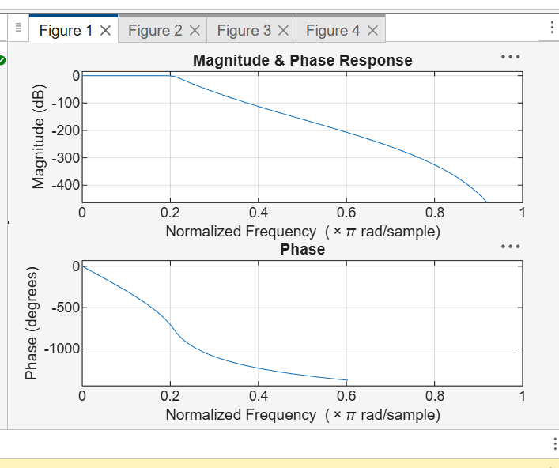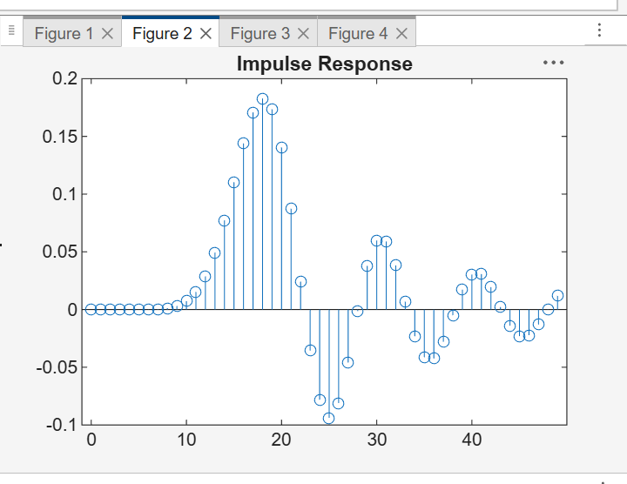

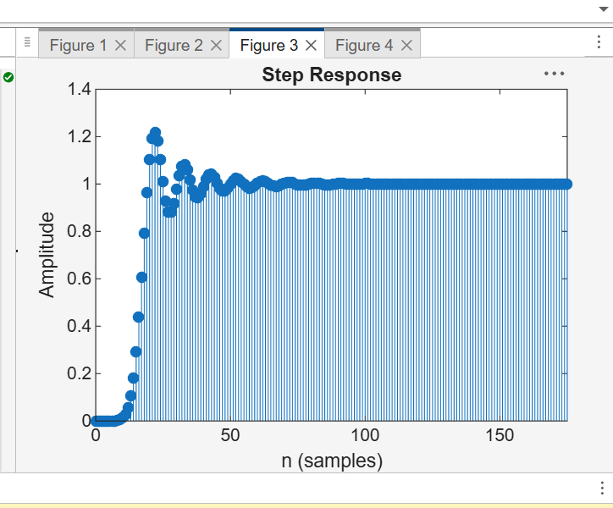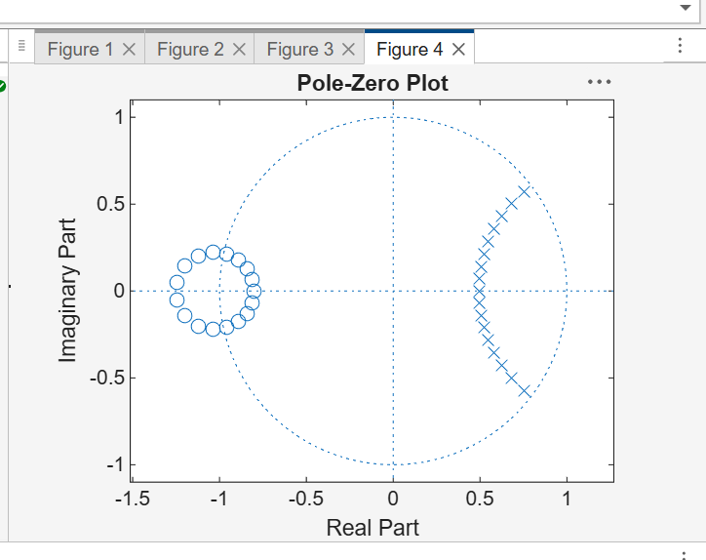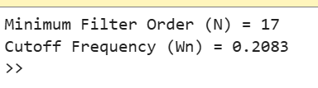
EXP-1 (1.2 )

clc; clear;

% EX NO:1
% Butterworth IIR Filters
% DATE:

% 1.2. Design and Analysis of a Butterworth IIR High-Pass Filter Using MATLAB

Fs = 10000; % Sampling frequency
Fp = 3000; % Passband frequency
Fst = 2000; % Stopband frequency

% Butterworth filter order and cutoff
[N, Wn] = buttord(Fp/(Fs/2), Fst/(Fs/2), 1, 60);
[b, a] = butter(N, Wn, 'high');

% Magnitude & Phase Response
figure;
freqz(b, a);
title('Magnitude and Phase Response');

% Impulse Response
figure;
[h, n] = impz(b, a, 50);
stem(n, h, 'filled'); grid on;
title('Impulse Response');

% Step Response
figure;
stepz(b, a);
title('Step Response');

% Group Delay
figure;
grpdelay(b, a);
title('Group Delay');

% Pole-Zero Plot
figure;
zplane(b, a);
title('Pole-Zero Plot');

% Display results
fprintf('Minimum Filter Order (N) = %d\n', N);
fprintf('Cutoff Frequency (Wn) = %.4f\n', Wn